**ORGANIZATION PROFILE**

NAME; **ROAD TO SUCCESS INITIATIVE**



REGISTRATION DETAILS:

REGISTRATION NUMBER OONGO/R/0114

BANK ACCOUNT: NMB A/C NUMBER: **22210020035**

A/C NAME: **ROAD TO SUCCESS INITIATIVE**

**FOUNDER**

RODRICK NABE

>>Public speaker

>>Author

>>Event organizer

ADDRESS;

P.O.BOX 20094 DAR ES SALAAM

+255 742 884 932

+255 674 502 925

successroad6@gmail.com

[www.roadtosuccess.co.tz](http://www.roadtosuccess.co.tz/)

**VISION**

A WORLD CLASS PROVIDER OF SELF DEVELOPMENT EDUCATION, INSPIRATION AND CONSULTANCY

**MISSION**

TO PROVIDE TRAINING, MENTORSHIP AND CONSULTATION ON ASPECTS OF PERSONAL DEVELOPMENT, CAREER GUIDANCE AND ENTREPRENEURSHIP SKILLS.

**CORE VALUES**

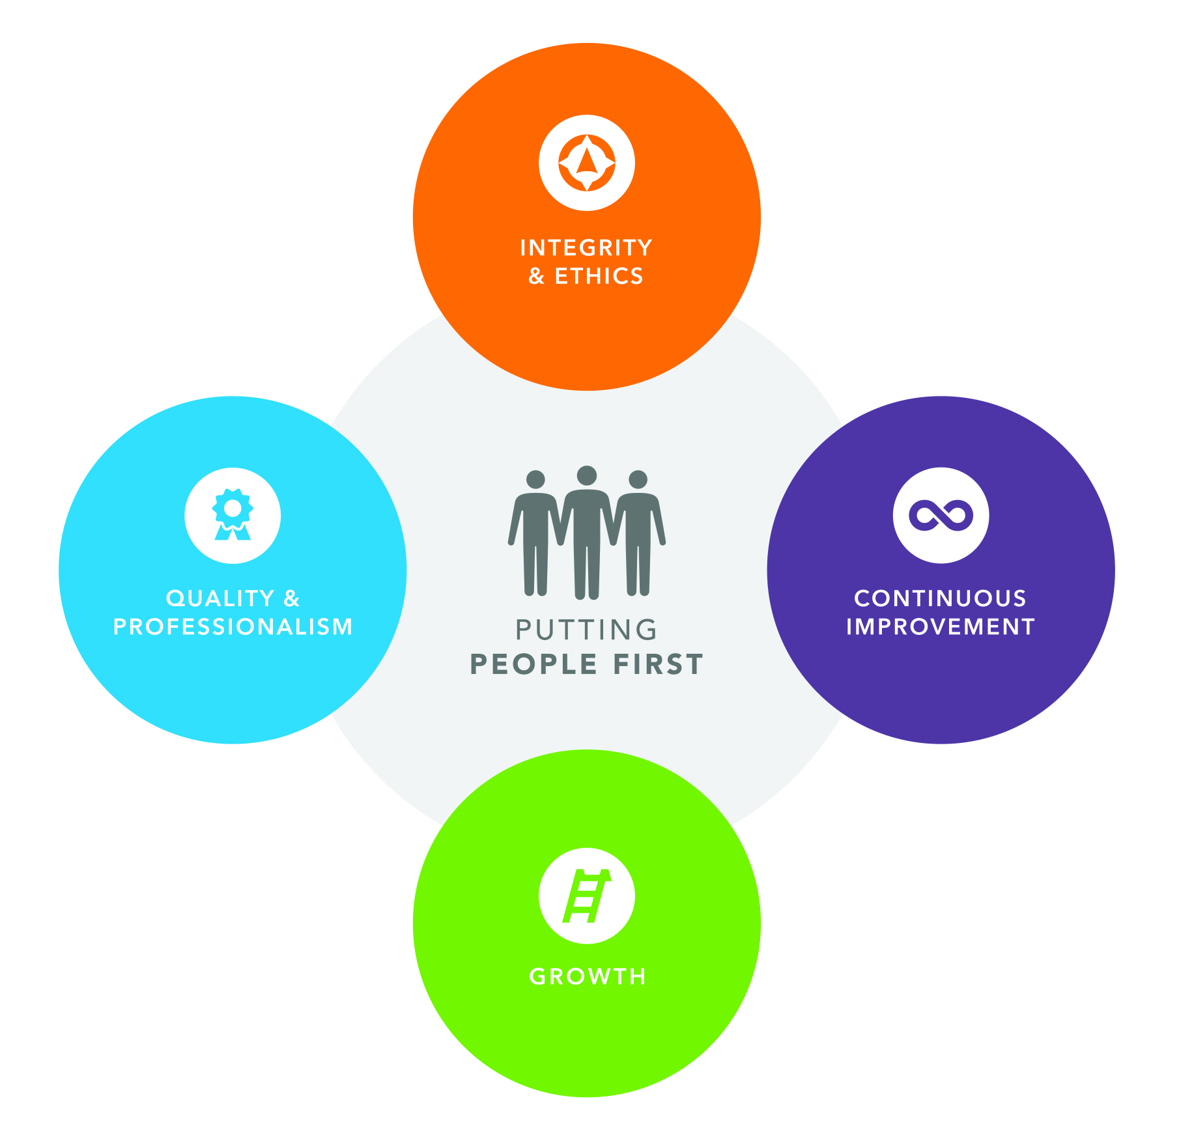

**FOCUS AREAS**

1.Personal development

2.Entrepreneurship

3.Career guidance

4.Gender awareness

**STRATEGIES**

>>Live seminars and on-line seminars

>>Audio-visual media

>>School campaigns

>>Family coaching

**TARGET GROUPS**

>>YOUTH

>>WOMEN

>>ENTREPRENUERS

**OUR PARTNERS**

-TONY INSPIRATIONAL TALK INTERNATIONAL

-CHRISTOM SOLUTONS

-HAPPINESS MASSAGE

-GLOBAL PUBLISHERS

-UNIVERSITY ABROAD REPRESENTATIVE

-RAFFLES GLOBAL

-MACHO KWA JAMII ORGANIZATION

-YEMCO TANZANIA

-VICOBA SUSTAINABLE DEVELOPMENT AGENCY

-MYLO AFRICA

-MC RHEVAN CO.LTD

-SINGO AFRICA

-FOFAM LTD

-FABI EVENTS

-GOODING AFRICA

-DAR ES SALAAM CLEANING SERVICES

-EVENTPEPTALK

**A FEW PHOTOGRAPHS**

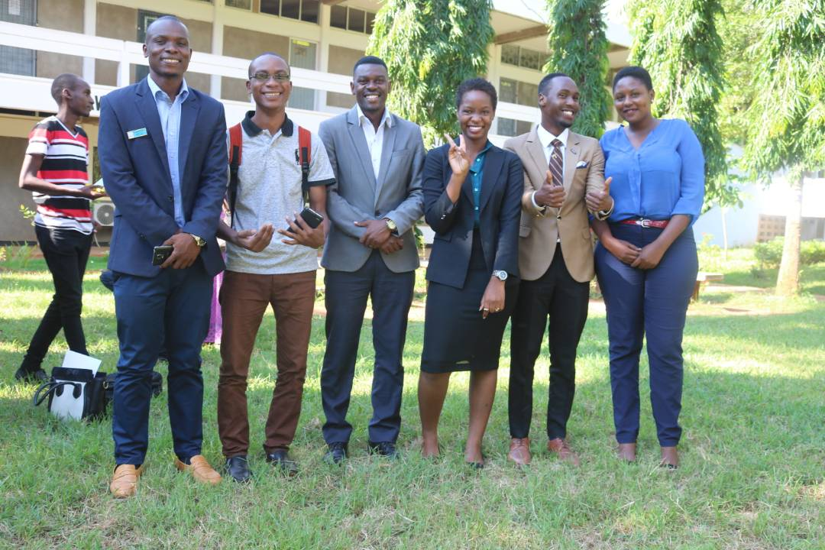

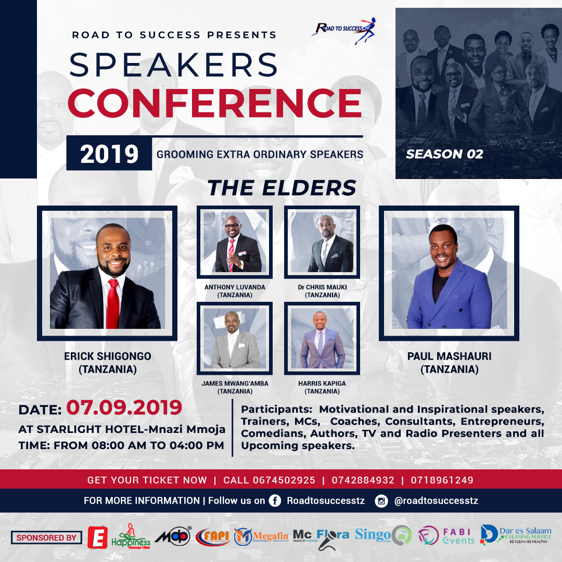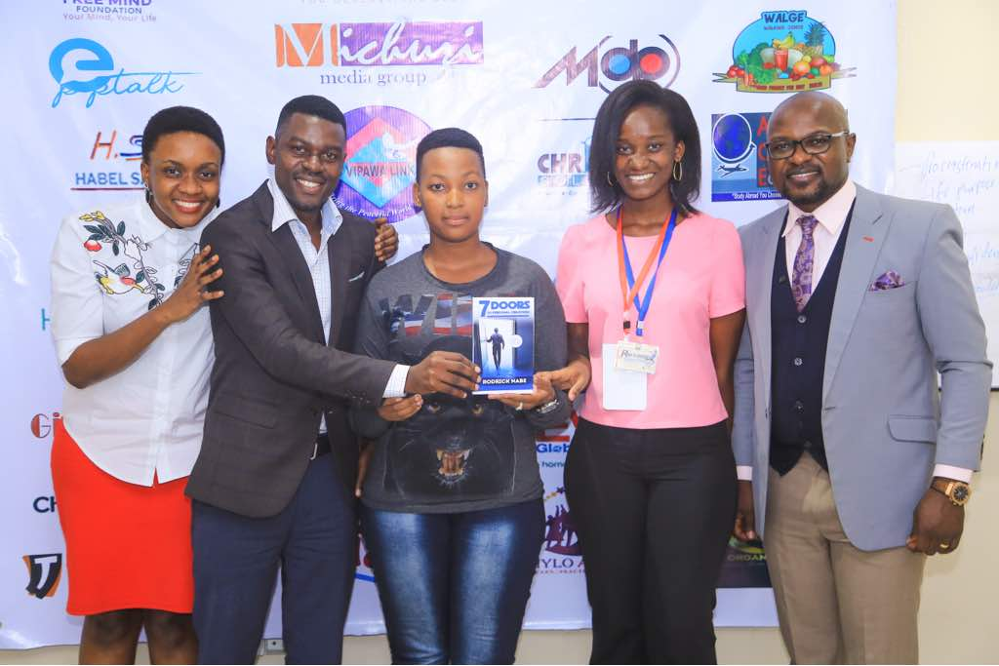

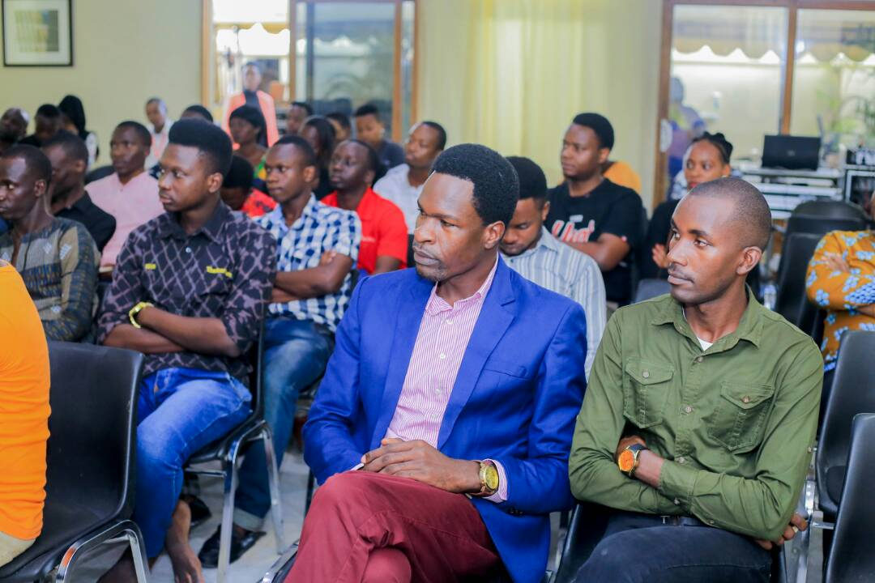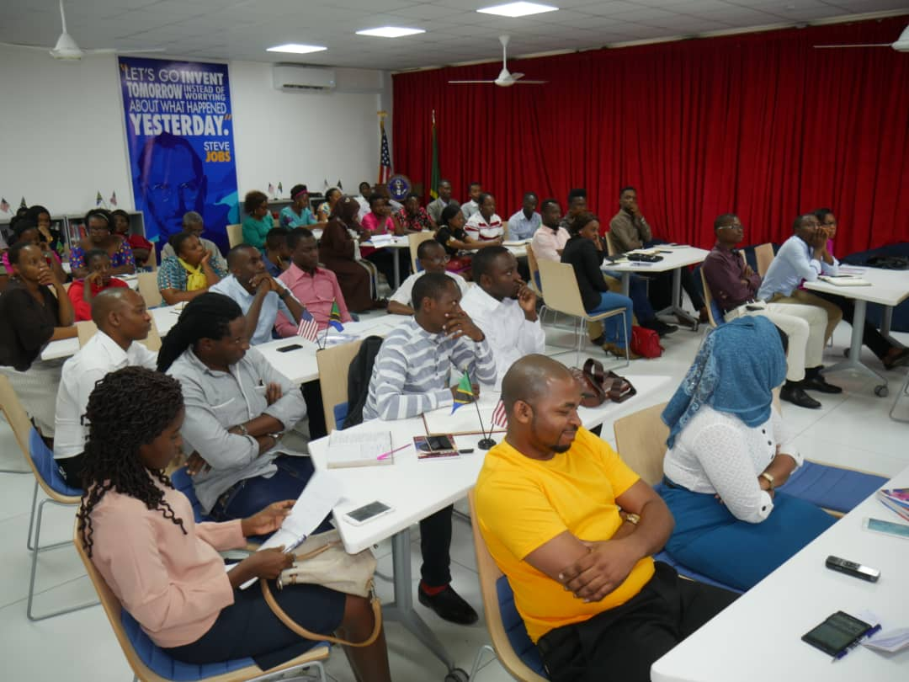

**MATERIALS AND TRAININGS AIDS**



