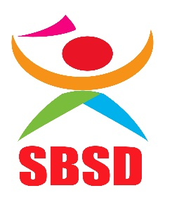Support Bridge for Students with Disabilities

(SBSD)
SBSD is a non-governmental organization that supports children with disabilities in schools and their families. It was registered as an NGO December 2017 (No. 00NGO/9401) operating in Tanzania Mainland. SBSD create addresses disability as a cause and consequence of poverty, and works in partnership with government and other stake holders to create an inclusive society for all. Currently, we are working with two regions Dar es Salaam and Mbeya and we have reached 1500 Children.
The reason why we decided to establish Support Bridge for Students with Disabilities is According to National Strategies of Inclusive Education developed by the Ministry of Education, Science and Technology and the President’s office Regional Administration and local Government with Technical Assistance of Cambridge Education and UNICEF, (2015/2016) Out of School Children Study” and found that there are approximately 3.5 million children and youth who are not receiving education. People with disabilities are often among the poorest and most marginalized in society. Disability has a significant impact on health, employment and education. More than half of children with disabilities do not attend school as a result of their health or activity limitations. Illiteracy among Tanzanians with a disability is 48%, compared to 25% among those with one. This seriously hinders social and economic development.
SBSD is committed to support children with disabilities in schools and their families for sustainable development, our motto ‘’we want all children with disabilities are empowered socially and economically for sustainable development’’. No easy task,but we have got the knowledge, passion and innovation to make a difference.

MISSION
To support social and economic empowerment for students with disabilities through research and trainings in collaboration with Government and other stake holders.

VISION
Tanzania where all students with disabilities are empowered socially and economically for sustainable livelihood.
OBJECTIVES
1. To improve access of education for students with disabilities
2. To promote empowerment and active participation for Girls and Women with disability
3. To fight against poverty from family level to the national level
4. To fight against injustice.
CORE VALUES
1. Listening and learning.
2. Taking responsibility for decision and making things happen.
3. Collaboration.
4. Creativity.
5. Integrity.
AREAS OF WORK
- Inclusive Education
- Health
- Livelihood Support
- Disability Rights
- Children Rights
- Empowerment of Girls and women with disability
- Disability and Sports
SOURCE OF FUND
- Entry and annual fees.
- Members contribution
- Individual donation
- Fundraising

TECHNICAL CAPACITY
SBSD brings in house technical expertise on social work, equality, child protection, Education, gender and advocacy to support vulnerable children to access education. We partner with local government and School management and Leaders in the Community to support children with disabilities in school.

SBSD VALUE OF MONEY
- Economic; Buying inputs of the appropriate quality at the right price.
- Efficiency; converting inputs to outputs through project activities.
- Effectiveness; project outputs achieving the desired outcomes on poverty reduction.

PARTNERS
We partner with local, regional, national and international organizations around the World who share its long term commitment towards persons with disabilities or inclusive for sustainable development.
SBSD, currently has partnership with:
- Ministry of Health Community Development, Gender, Elderly and Children
- Tanzania League of Blind (TLB)- Dar es Salaam
- Tanzania Federation of Disabled People’s Organizations (SHIVYAWATA)-Dar es Salaam
- Tanzania Albino Society- Ubungo district
- Local Government Authority- Rungwe district
- School Committee, teachers, parents of children with disabilities, matrons, patrons- Katumba II primary school and Uhuru mchanganyiko primary school.

RUNNING PROGRAMS
- My Voice My school Program
My Voice My School (MVMS) Program gives children the opportunity to share their ideas about education and their future.
My Voice My School deals with the problem of high dropout in target schools, increases children’s attendance in classrooms and improves learning through safe, child-friendly and healthy environment that bring children the opportunities to unlock their potential. During its life journey. My Voice My School has had an impact on large number of children with their access to and facilities in schools.
The goal of My Voice My School for children in Schools is an education program which seeks to empower vulnerable children by giving them a voice and an opportunity to communicate on issues that related to them. Promote children rights, Creativity, and innovation as well as the acquisition of hands on operative capabilities among them and it puts children at the heart of the conversation about what the sustainable development in the country.
My Voice My School program, we are working in collaboration with teachers, at Uhuru Mchanganyiko and Katumba II primary school, My Voice My school clubs include children with and without disabilities to ensure inclusive education. So far we have reached approximate not less than 1500 children in schools.
Through this project children with disabilities are encourage to speak up, take part in their learning and become confident citizen.
Everything we do depends upon the efforts of our volunteers.
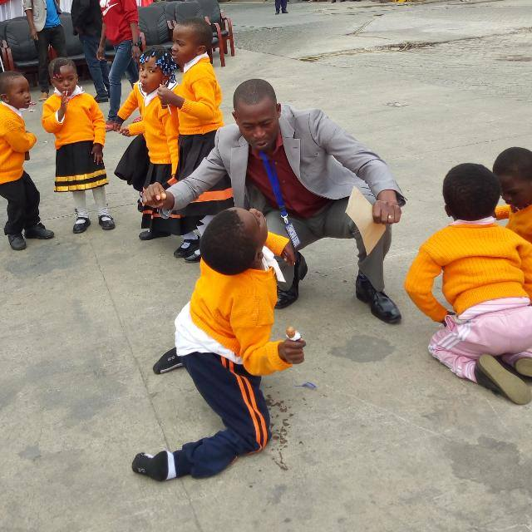
Annex: 1 My Voice My School club
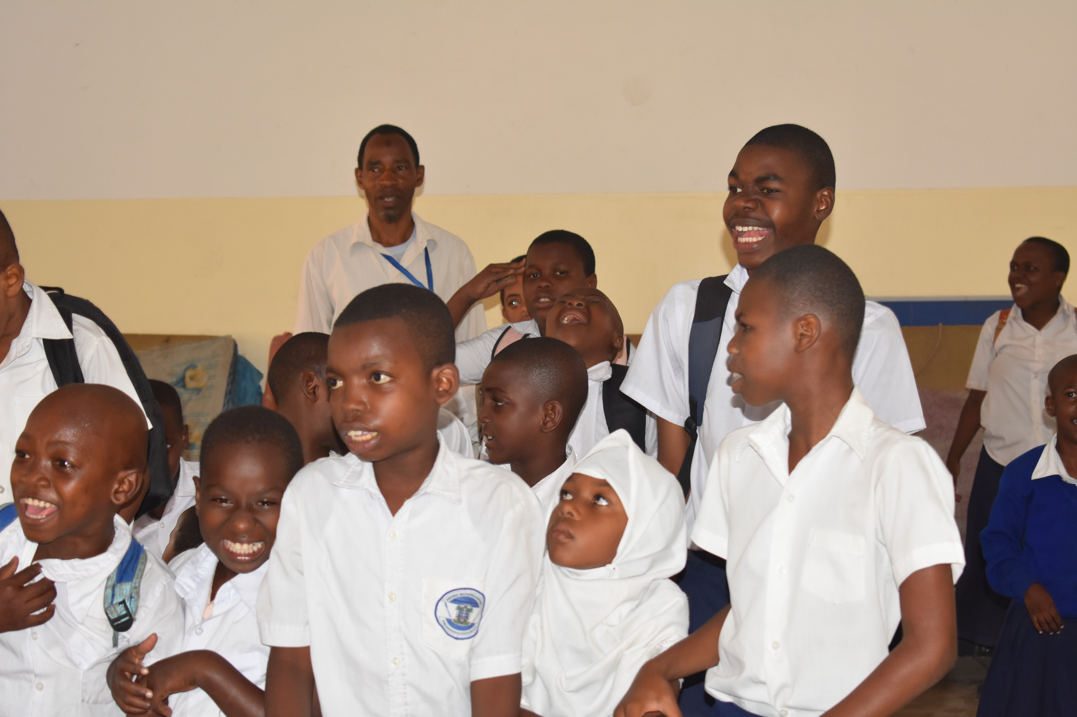
Annex 2: My Voce My School club, children they are enjoying their session.

- School Feeding Program
SBSD providing food to school, School Feeding Program has been found necessary due to poverty levels in the community where the children don’t have enough to eat at home make them eat at school.
School Feeding Program gives an opportunity to provide a nutritious meal to the children and has boosted their health by reducing the number of children suffering from Malnutrition.
SBSD through School Feeding program in collaboration with community members at Rungwe district and parents of children with disabilities we have managed to feed more than 500 vulnerable children at Katumba II primary school.
SBSD believes that schools where feeding program is in place, children retention and school attendance reaches almost 100%.
Everything we do depends upon our fundraising efforts.

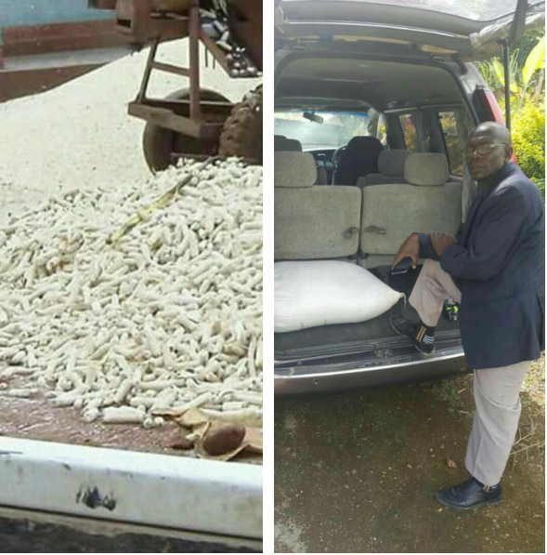
Annex 2: School Feeding Program

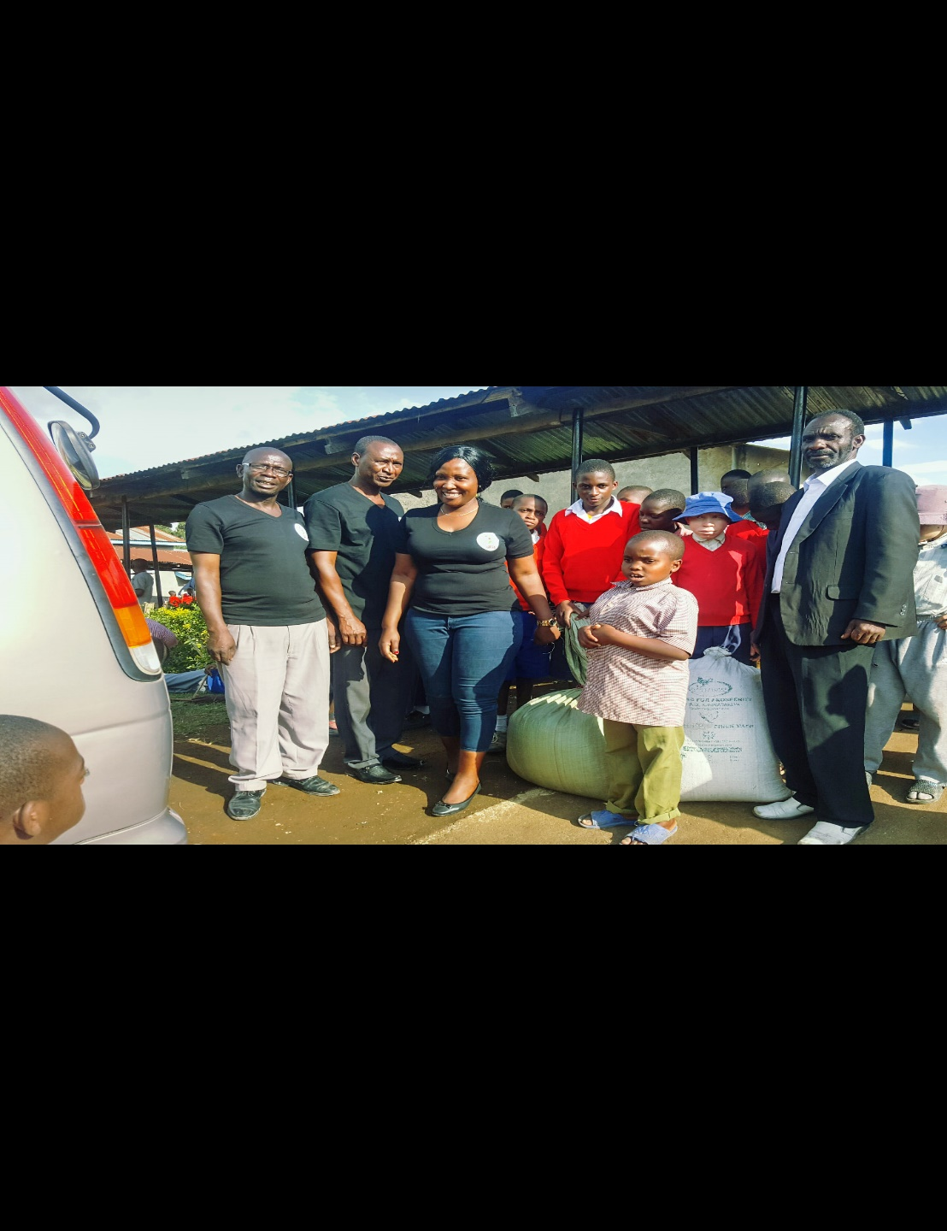
Annex 3: School Feeding Program

- Home Visiting Program.
SBSD paying a visit to people with disabilities and families of children with disabilities make them feel loved, needed, befriended, cared, supported, accepted, present, wanted and appreciated.
The aim of Home visiting is to share experience of life for the people with disabilities and the families of children with disabilities who are living in poverty and to see on how we can empower them socially and economically for sustainable livelihood.
According to Mantra for a movement slogan of the persons with disabilities ‘’Nothing About Us Without Us’’ emphasizes how people with disabilities must be valued as integral and essential contributors to every sector.
So far we have reaches 5 families of persons with disabilities in Dar es Salaam region.
We are working in collaboration with community leaders on the surrounding area of the implementing program.
Everything we do depends upon our fundraising efforts.
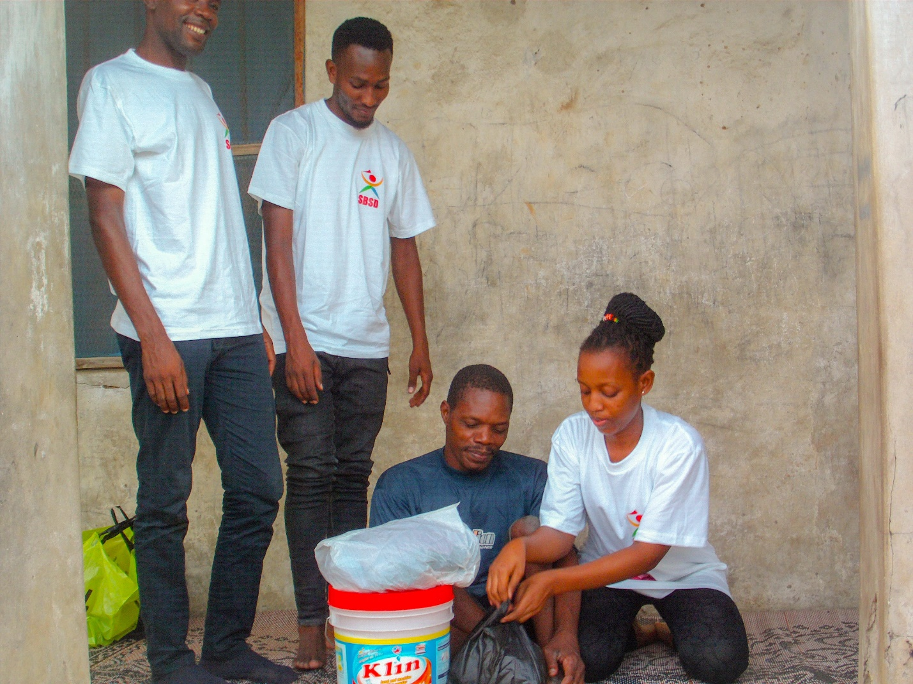
Annex 4: Home Visiting

- Empowering girls with disabilities in schools Project
SBSD empowering girls with disabilities in schools through access to quality education for all girls with disabilities on the surrounding community and teaching girls with disabilities about their rights.
SBSD is dedicated to empower girls with disabilities by ensuring the access of quality education for all girls with disabilities, by providing hygiene education, ending violence against girls with disabilities in schools, promoting the rights of girls and women with disabilities to support the elimination of discrimination and violence against women and girls with disabilities.
We are working in collaboration with teachers and matrons to ensure the empowerment of girls with disabilities in schools. So far we have reach 232 girls with disabilities in schools.
Everything we do depends upon our fundraising efforts.
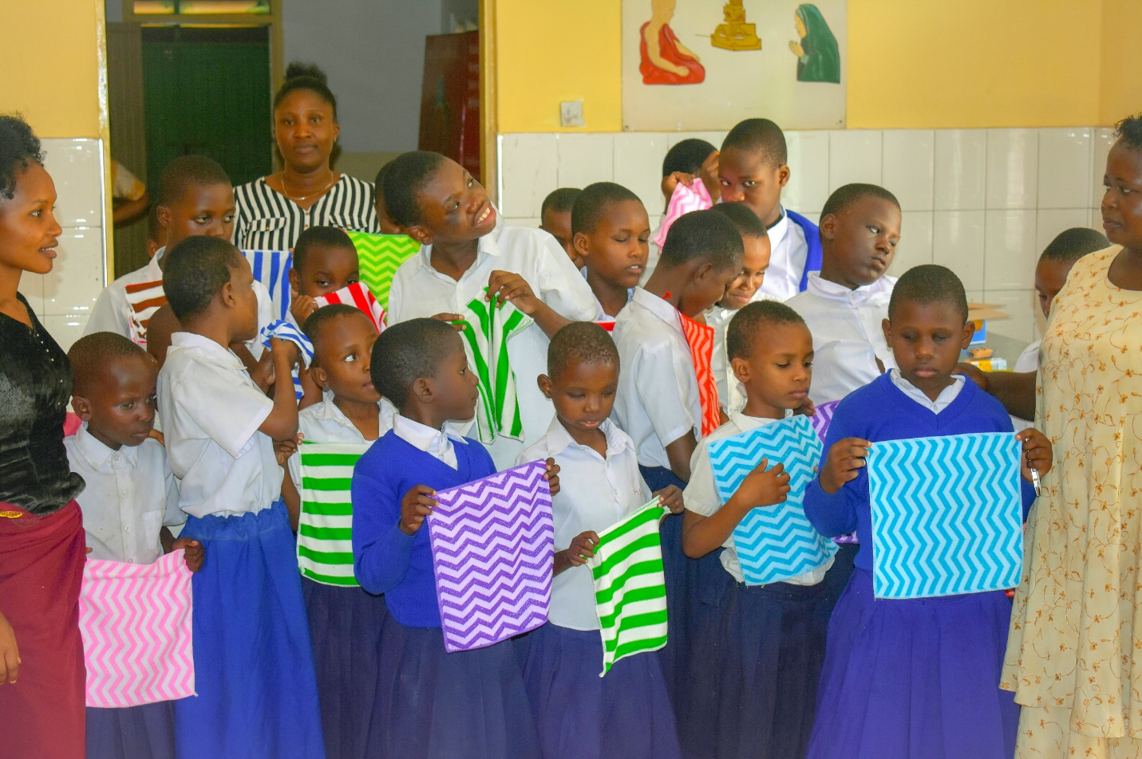
Annex 5: Empowering Girls with disabilities in schools

- Disability Sports Program
SBSD believe that Sport is able to provide immediate and long-term relief to children with disabilities have an equal opportunity to live a full, active and healthy lifestyle in schools through sport and active recreation.
At Katumba II primary school we are ensuring sports to children with disabilities although we are doing this locally because we don’t have funds and equipment for sports and this depends on the efforts of our volunteers in the collaboration of teachers.

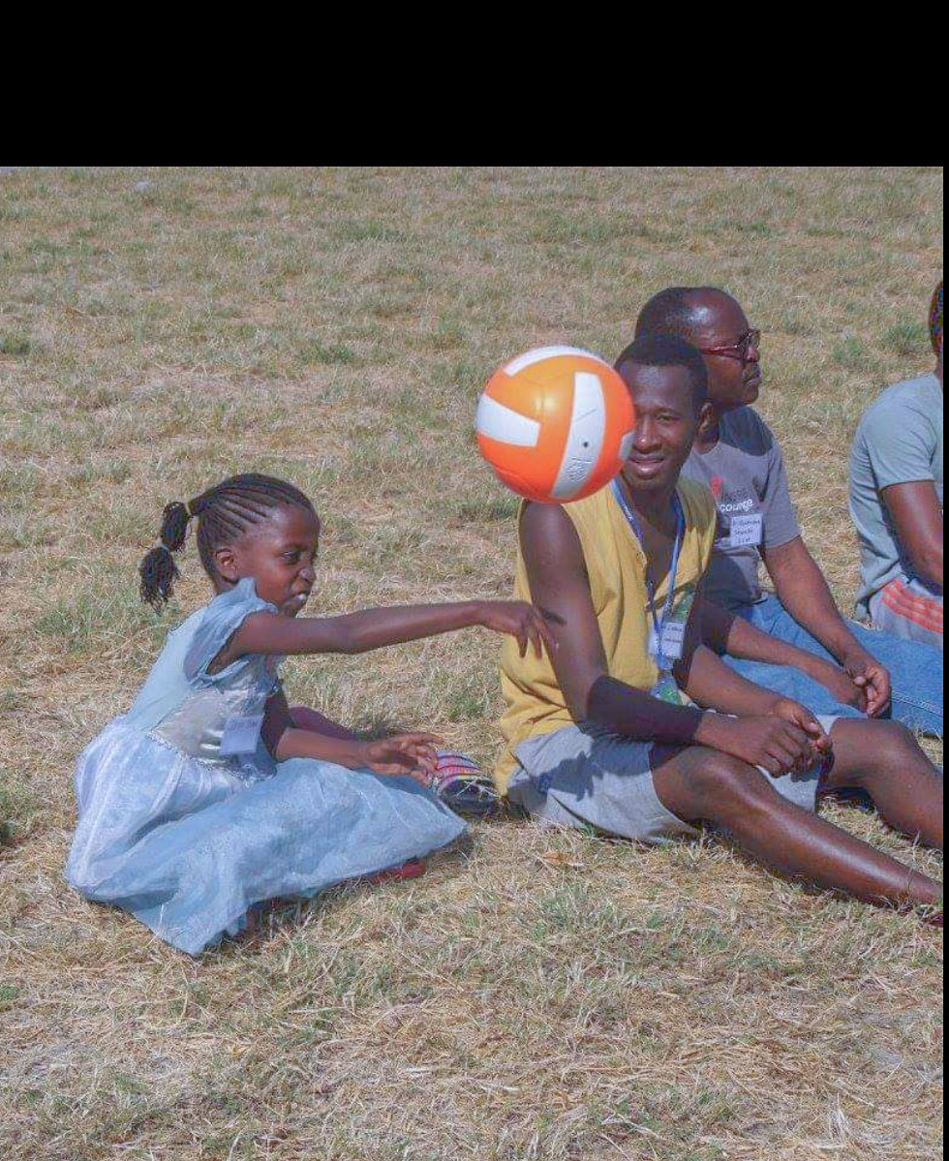
Annex 6: Disability Sport

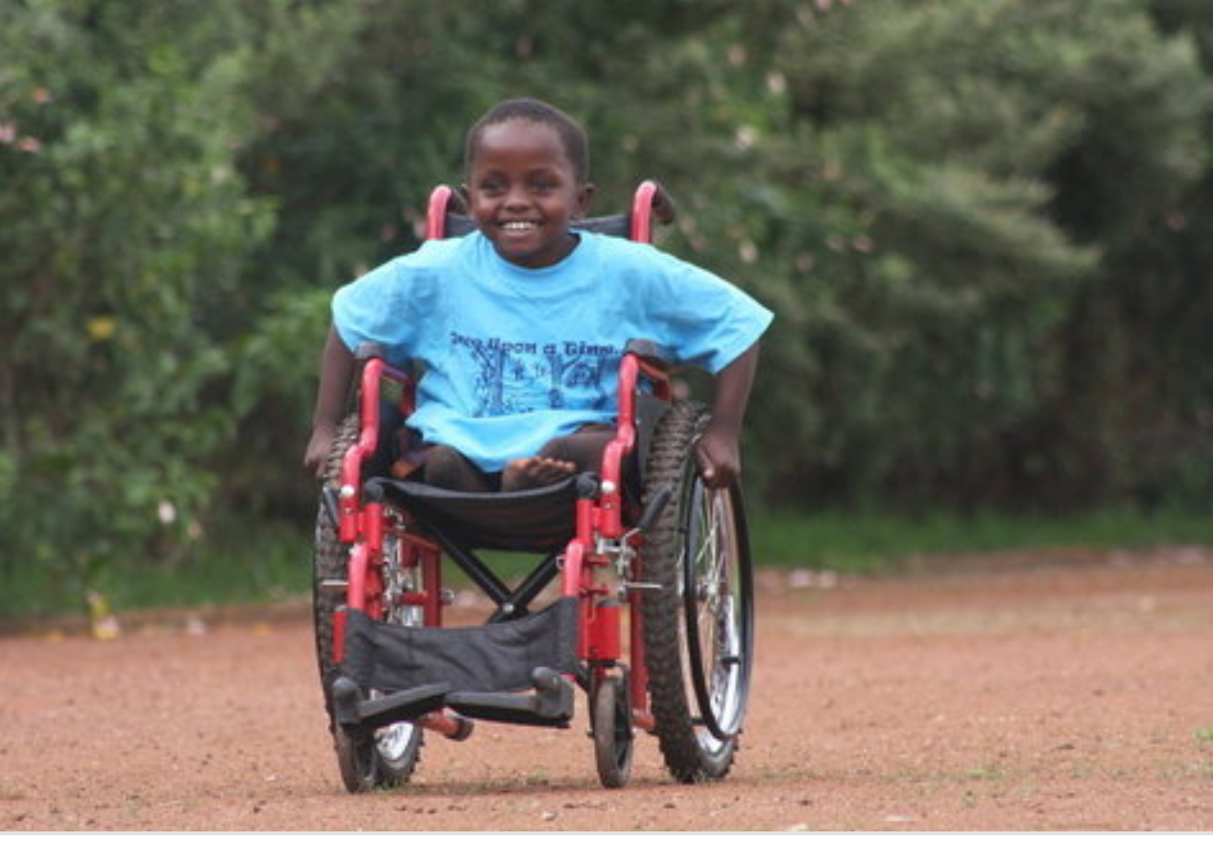
Annex 7: Disability sport

SBSD KEY STAFF
- Tukuswiga Ofman, Chief Executive Officer
EDUCATION
- Bachelor of Arts in Sociology and Social Work (BASSW) From September 2011-July 2014 Mwenge University College of Education (MWUCE) a constitute college of St. Augustine University of Tanzania (SAUT).
- Tukuswiga Ofman based on her professional of Sociology and Social Work she is motivated to do whatever she can to provide resources and assistance to vulnerable children with disabilities in Tanzania.
EMPLOYMENT EXPERIENCES
- March 2017- Present, Chief Executive Officer (CEO) at SBSD Tanzania
- March 2013 – July 2015, Project Officer at Child reach International Tanzania
- May 2015- June 2016 Site Supervisor for Enumerators at National Bureau Statistics (NBS) Tanzania
- June 2012- February 2013 VCT / HIV Counselling and Testing at St. JOHNHUS Center, Tanzania

- Jacob Magehema -Administrative & Finance Manager
EDUCATION
- 2018/2019: Masters in Project Management program, Open University of Tanzania
- 2018: Certified Public Accountant (CPA-T) - Final stage
- Jun 2012: Bachelor of Commerce in Accounting, University of Dar es Salaam (Finance, Accounting, Marketing business Law, Taxation, business mathematics and Business Management subject
- Feb 2010: Advanced Certificate of Secondary Education, Minaki High school (Business studies)
- Nov 2007: Certificate of Secondary Education, Pandahill Secondary School (Both Science & arts subjects)

EMPLOYMENT EXPERIENCES
- January 2018- Update : Administrative & Finance Manager at SBSD Tanzania
- 2014 – June 2017: Grant Finance Manager at Plan International Tanzania
- January- May 2014: Finance & Admin Manager at Social Economic Development Initiative of Tanzania-SEDIT (NGO
- 2013 June-December: Chief Accountant at Durban Hotels in Dar es Salaam

- KEMA KORONEL MASHALLA - Program Manager
EDUCATION
- Ardhi University (former known as Ardhi Institute), Dar es Salaam – Oct.1983 to March 1986, Advanced Diploma in Public Health Engineering
- University of Leeds, UK: Oct. 1995 to June 1997, MSc (Eng.) in Tropical Public Health Engineering
- USAID/Measure Evaluation/msh – Nov. 2010 to March 2011, Diploma in Virtual Leadership Development Program (VLDP).
- Certificate issued by Centre for Housing Studies of Ardhi University (formerly Ardhi Institute) and Institute for Housing and Urban Development studies (formerly known as Institute for Housing studies.
- The Netherlands – Jan to April 1989, Certificate in Water supply and Low cost Sanitation.
EMPLOYMENT EXPERIENCES
- March 2017 update, Program Manager at Support Bridge for Students with Disabilities (SBSD) Tanzania
- December 2015 to date, Programme Manager/Head of Programmes at Sight savers Tanzania
- Aug. 15th 2014 to November 2015, Program Manager at Plan International Tanzania
- July 2006 to April 2013, WASH Technical Lead at AMREF Tanzania
- October 2000 to March 2003, Health Projects Officer at British Council Tanzania

- Sekelo Anangisye -Human Resources Manager
EDUCATION
- Oct 2012 to July 2015: Administration with Education (BBA-Ed), at Stefano Moshi Memorial University College.
EMPLOYMENT EXPERIENCES
- 2015 – Update, Human Resources Manager at SBSD Tanzania

- Lusubilo Joshua - Educational Coordinator
EDUCATION
- Bachelor of Arts with Education (BaED), University of Dar es Salaam from Aug. 2012 – July 2015
EMPLOYMENT EXPERIENCES
- July 2015 – update, Education Coordinator at SBSD Tanzania
- November 2016 –October 2017, Teacher at St. Marry International
- Feb 2016 – July 2016, Teacher at Laureate International Secondary School
- July2015 – October 2015, Research Assistant at University of Dar es salaam – School of Education
- June 2014-Sept 2014, Teacher at Gonzaga seminary secondary school

ORGANIZATION STRUCTURE.
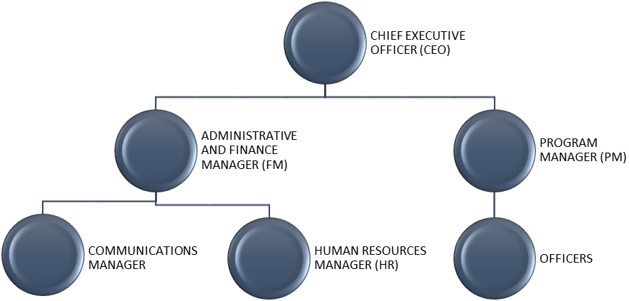

CONTACT PERSON.
Name; Tukuswiga Ofman
Position; Chief Executive Officer
Email: ofman@sbsd.or.tz
Mobile: +255765309148
Website: www.sbsd.or.tz

