

NYUMBANI RABBIT FARm & supplier



C:\Users\Lanoditas\Desktop\Mobile-Rabbit-Wallpapers.jpg

1. EXCUTIVE SUMMARY.

Nyumbani Rabbit Farm & Supplier (NRFS), is the formal registered business, under Tanzania business names Act. As a company NRFS deals with selling of hybrid rabbit, conducting seminars and training for rearing rabbit for commercial, Rabbit feeds, and marketing of rabbit products. With ability and room for expansion rabbit production as the potential to ensure food security, improved nutritional status, as well as reducing poverty marginal of small farmers and their families. Because rabbit production boosts Agricultural production and income generating opportunities.

Our vision is to become the leading fully integrated producers, distributor, Wholesaler and retailer of rabbit products in Tanzania.

Our Mission, to improve nutritional status and livelihoods by producing alternative source of income through sale of rabbit by-product.

The name Nyumbani, which means “HOME”, aims to popularize rabbit meat in Tanzania and ensure readymade market for Rabbit breeders in and out of Tanzania as well as creating a culture of buying local so as to strengthen our County’s economy.

Our company has established its mission on a social enterprise, aiming to device a pro-poor business model which could potentially convert poorly remunerative convectional breeding of rabbit into commercial viable breeding which can lead to significant and sustainable livelihood opportunity.

2. BUSSINESS DISRCPITION.

Nyumbani Rabbit Farm & Supplier focuses on revolutionalizing rabbit breeding in Tanzania from convectional breeding to commercial viable breeding. by envisioning strong Rabbit Breeders (out growers) who NRFS sells to them hybrid rabbit at affordable prices, offer technical consultation on rabbit rearing and ensure them with the rabbit feeds and market of all rabbit products like meat, urine, and skin. Why choosing rabbit;

* There is a growing domestic demand for the cholesterol free meat amongst the burgeoning middle and upper income brackets in our urban population. Over 26 per cent of the Tanzania's adult population are overweight, and 7 per cent others obese. thus putting them at higher risk for no communicable diseases such as heart ailments (Global Nutrition Report).
* Rabbits are the most productive of domestic livestock. A rabbit only takes 4 months to grow. Their gestation period is only 28-30 days and a female rabbit on average, gives birth to 30 young ones per year ,a doe(Female rabbit) can become pregnant again within hours of giving birth.(Courtesy,of P.R. Cheeke)
* They occupy little space hence suitable for most urban areas for small scale rabbitry. They are quiet animals that can be raised in any environment. They rarely get sick unless kept in unhygienic conditions
* Their meat is white, high in protein and low in fat and cholesterol. Protein is important for healthy cellular processes and functions that in turn support tissue development, repair, and maintenance. the lowest fat content in the meat as compared to other meats. In addition, 63% of rabbit meat’s fat is unsaturated fat, which is regarded as the good fat. also low in calories compared to all similar white meat Its health advantages make it high on demand especially in restaurants, hospitals and hotels.
* Rabbit farming is not complicated and requires less professional skills, which makes it suitable to engage in. They live for 8-12 years and the climate in East African region is appropriate for rabbit farming. Different Rabbits breeds that can be reared in Tanzania are Californian, Chinchilla, Flemish Giant, New Zealand White, ILRI Giant, Dutch and French Lope. All those breeds are suitable for commercial production according to the environment and climate of Tanzania.

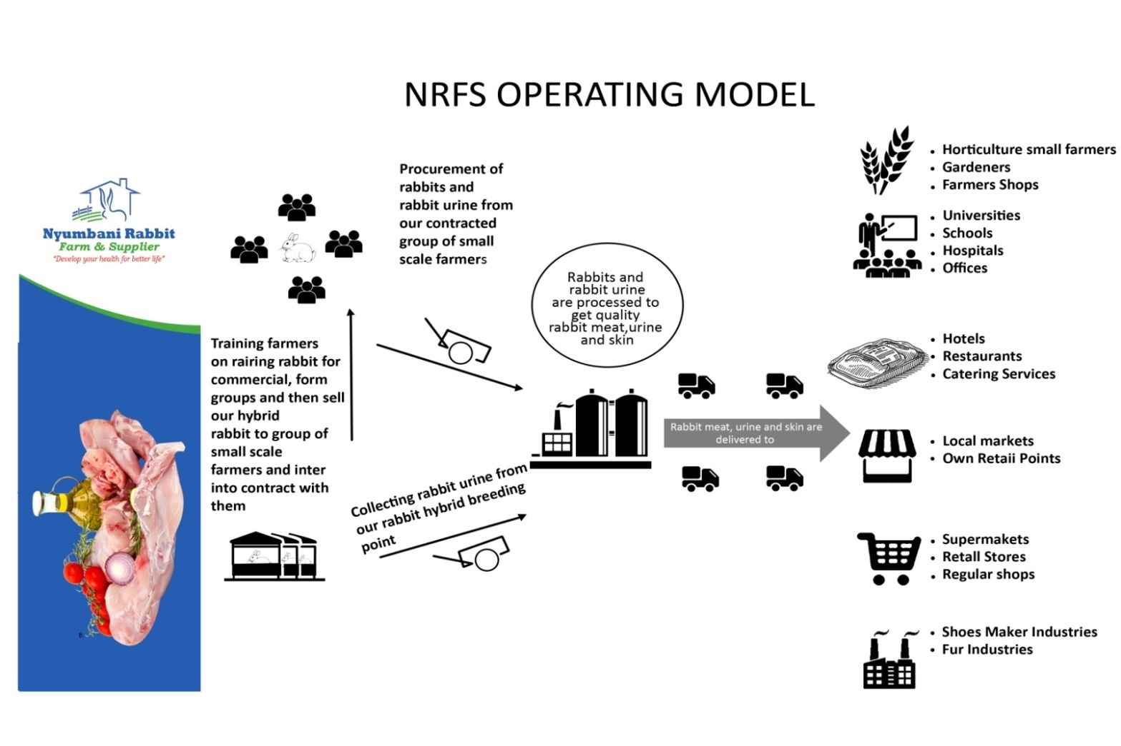

3.0 MARKET ANALYSISS.

In sub-saharan Africa meat consumption is growing so fast, that capacity is not meeting demand. This change in meat consumption has been driven in part by taste, health lifestyle also austerity as consumers have hooked to an affordable source of protein. Other observation that support continued growth in meat consumption are (United Nations), the share of the working age population in Sub Saharan Africa is set to rise from 55% to 65% by 2050, adding more than 680 million workers and subsequently wage consumers; (McKinsey Global Institute), households in Sub Saharan Africa earning more than US$ 2 500 annually is set to rise to almost 70% from less than 50% in 2000 and (IMF), African economies are growing on average at a rate of 5.5% as compared to a 4% global average, which means more consumption.

In Tanzania the commercial sector for meat is underdeveloped and only few companies like The rabbit bliss ltd, Exrapt Tanzania, Ruvu JKT, Twiga feeds and Hill feeders (all in Dar es Salaam), Kilivia Feeds (in Pwani) have established large scale poultry for the urban market. Due to their brand, most of them sells rabbit hybrid at the cost of 100,000/Tsh for 1 rabbit and selling rabbit pallet(food) at the cost of 2,000/Tsh per 1 Kg.

But we NRFS we are selling rabbit hybrid at the cost of 45,000/Tsh per one hybrid and our feeds is 850/Tsh per 1 Kg. Since we have established rabbit out growers groups, we buy again rabbit for meat(with 2.5 Kg) from our out growers at the cost of 10,000/Tsh and transporting it to our packaging area at a cost of 85/Tsh and slaughter it at the cost of 250/Tsh.

-To white meat butchersl 1 Kg of rabbit meat is sold at a cost of 7800/Tsh. But to supermarkets and Hotels the cost rises up to 15,000/Tsh per 1 Kg due to the cost related with packaging and transport for delivery. Currently we are supplying up 145 kg to hotels, supermarket, restaurants and 100 kg in local butchers. We aim to at least supply 500 kg per month by end this year.

3.1 MARKETING STRATEGIES.

Nyumbani Rabbit Farm & Supplier sets reasonable and affordable prices that will covers all cost of sales and administrative costs and remain with a reasonable Profit margin. Apart from pricing, Nyumbani Rabbit Farm & Supplier creates awareness to the public about rabbit by- products. In this strategy, the company advertise through various ways such as television, radio, magazine & newspapers example the first 2 times these print ads run, we include a coupon for a discounted product. Also sigh board, business card, brochures, leaf let, printed packaging materials and Social media like Facebook, Twitter and website will be used to widen the market.

Other way is participating in organized regional, national and East Africa Common Market Trade Fairs, lobbying big and small restaurant to start offering rabbit cuisine, We will also promote consumption of rabbit meat as a healthier lifestyle by avoiding diseases associated with red meat such as gout, high cholesterol, heart diseases and the like, the whitest with its cholesterol level being much lower than chicken, turkey, beef, and pork. Suitable for special diets such as those for heart disease patients, diets for the aged, low sodium diets, and weight reduction diets .Also home delivery for families, working class, expats and Chefs, branding and marketing of product and services by having an online portal where customers can place their orders electronically.

Also as a way to popularize rabbit meet in Tanzania’s Culture, NRFS will be supplying rabbit meet to nearby residential areas as our main distribution points like butchery at affordable price, Fast food outlets, areas where they make foils(Mishikaki), sausage, restaurants, Big hotels, Supermarkets Mama ntilie’s. And letter on to open our own network of outlets so as to double our meat sales and advertising ourselves through supplying Branded Product.

**4.0**

**SWOT ANALYSIS.**

|  |  |
| --- | --- |
| **STRENGTHS** | **WEAKNESSES** |
| -management team  -Value chain integration  -Wide range of rabbit-by products  -Feed and resulting product quality | -Feed conversion rates  -Low capacity utilisation  - Middle management capacity    - Insufficient funds for modern Processing plant and modern rabbit slaughters place  -Logistics  - Our level of technology example in food processing machine, and packaging materials |
| **OPPORTUNITIES** | **THREATS** |
| -Improved ICT  -Healthy eating (white meat campaign versus red meat)  -Franchising the retailing concept  -Increased population  -Exploit new market segments  -Product development | -Disease  -Customer's Low knowledge about our products  - competitors have stronger reputation  -High cost of credit  -High cost of power, erratic supply  -Feed quality, high cost and availability |

5.0 MANAGEMENT & ORGANIZATION

4.1 LEGAL FORM OF BUSINESS

Nyumbani Rabbit Farm & Supplier is the a formal registered business registered under Tanzania business names Act (Cap 213) by Business Registration and Licensing Authority of Tanzania (BRELA) entered with index number of registration 411443 TIN 130- 670-687.NRFS own an account at National Microfinance Bank and the Account number is 24310004535.

4.3 COMPANY ORGANIZATION STRUCTURE

Nyumbani Rabbit Farm & Supplier will operate in an organized structure to Easy business operations. The organisation’s structure will include:

BOARD OF DIRECTORS

This will be the supreme organ which will take the responsibility of making all decision pertaining the organisation affairs. Boards of directors will be formed by the first four shareholders of the organisation.

Production Department

Production department will be headed by Production Manager and will be responsible for production of enough animal for meet. The department will ensure availability of enough rabbits and identifying other rabbitarians who could work with us in the chain.

Finance & Administration Department

Finance & Administration department will be headed by finance & Administrative Manager. The department will be responsible for marketing all Organisation products and all administration matters including finance and staffing. The following below is the proposed organization structure.

Organization structure

Board of Directors

Production Department Finance & Administration Department

4.4 MANAGEMENT DESCRIPTON.

Management of the business will be vested on the hands of Board of Directors. The Board of Directors will be the supreme organ which will take the responsibility of making all decision pertaining the company’s affairs. However the day to day activity of the organisation will be led by the Managing Directors who will be responsible for implementing all board resolutions. Planning coordinating, and supervising company’s activities. The Managing Directors will be supported by Department Mangers. The Department managers, each will be responsible to his/her department and ensures company’s activities are performed accordingly so that to achieve the planned goals.

Company’s Management structure

Board of Directors

Managing Director

|  |
| --- |
| Chief Operating Officer |

Production Manager Finance and Administrative Manager

Food Technologist Production Accountants Marketing&

Quality Control supervisors & sales

officers

Drivers Machine

Operato

Drivers Secretary Security

guards

**6.0 FINANCIAL PLANS**

The Board of Directors through management team will make sure that the organisation has a reasonable number of rabbit before starting supply meeting and enough working capital with human resources.

Capital expenditure is as follows.

|  |  |  |  |
| --- | --- | --- | --- |
|  |  | FINANCIAL REQUARMENT |  |
| Capital Expenditure | machinery | Food processing machine | 8,725,000 |
|  |  | Meet hangs | 500,000 |
|  |  | Weighing Scale | 500,000 |
|  |  | Freezer | 4,000,000 |
|  |  | Cold room | 15,000,000 |
|  |  | meat cutter | 2,000,000 |
|  | Marketing | Fliers ,brochure& Business cards | 1,000,000 |
|  |  | Ambassador | 3,000,000 |
|  |  |  |  |
|  |  | Packaging materials | 800,000 |
|  | Working Capital | Salaries(6 month) for 3 people | 9,000,000 |
|  |  | raw materials | 4,500,000 |
|  |  | Renting an office | 5,000,000 |
|  |  | TOTAL | 56,025,00 |

**In a simple form pie chart representation of Capex**

NYUMBANI RABBIT FARM & SUPPLIER SCALE UP PLAN

