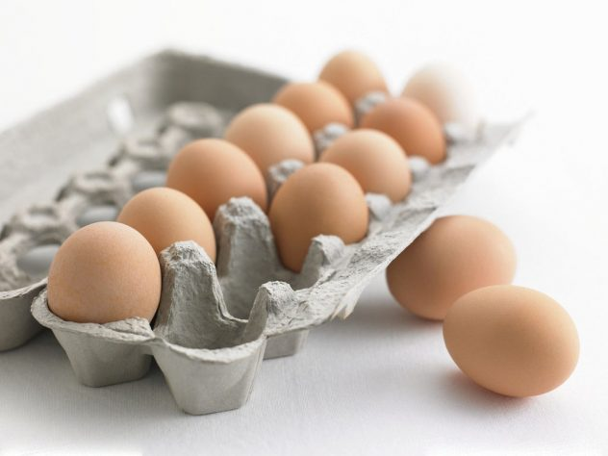

SHITINDI POUTRY FARM AND HATCHER

**BUSINESS PLAN 2017**

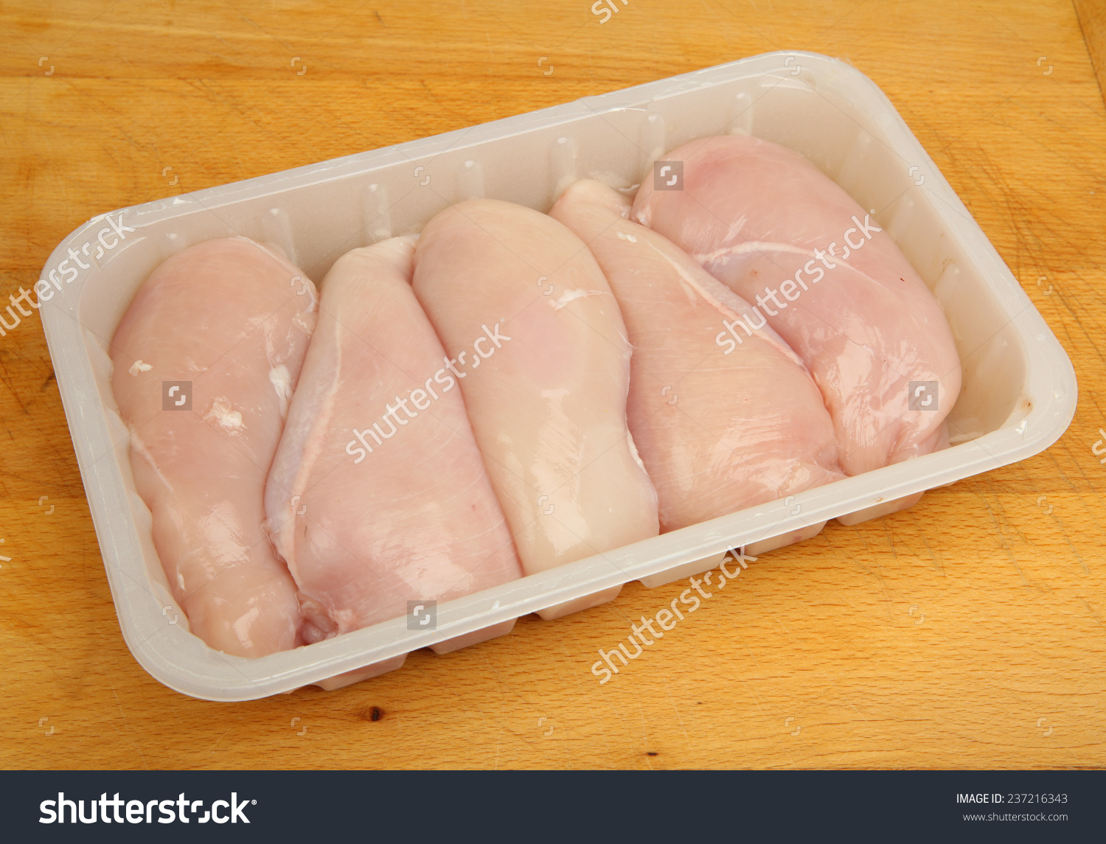

|  |  |  |  |  |
| --- | --- | --- | --- | --- |
| DAR ES SALAAM, TANZANIA. |  | Mob. +255 713 071 701  C:\Users\SAM\Desktop\poster\whatsapp.png +255 713 071 701 |  |  |

Table of Contents

1. 1.0 EXECUTIVE SUMMARY 2
2. 2.0 INTRODUCTION 3

2.1 Vision

2.2 Mission

2.3 Values

2.4 Goals and Objectives

1. 3.0 PRODUCT AND SERVICE DESCRIPTION 5

3.1 product description

Future products

3.2 Service description

Future services

Market

1. 4.0 ORGANIZATION AND MANAGEMENT TEAM 7

4.1 Organizational chart and description

4.2 SWOT analysis

4.3 Legal structure of the business

1. 5.0 APPENDIX 10

5.1 forms

5.2 advertisement

5.3 prototypes

# 1.0 EXECUTIVE SUMMARY

SHITINDI Poultry Company is focused on both eggs and meat production that provides for a large market range. It also produces manure as a byproduct. It is based in TANZANIA, but we are focusing in expanding to other COUNTRIES and finally across WORD. We have noticed the health implication of red meat and are creating a business to meet the increased demand for white meat and eggs.

Chickens happen to be a great source of white meat and are also largely known for eggs production. The persons who have come together to start this business (founders) IS AHADI AUGUSTINO MLEWA.

Not only a founder is interested in meeting the demands of the customer, we also plan to create utmost satisfaction for these customers. The founders also want to use this business as a means of creating employment within the community it is based in and to contribute to the economy of the country. We plan on provide products with quality and maintain this supply efficiently

This is a partnership business that plans on distributing eggs and chicken to restaurants, home delivery, food centers, hotels, schools, government institutions, bakery and catering businesses and supermarkets. We also plan on doing this at very affordable prices. We will also distribute manure to farmers that are into crop production.

This business plan for poultry farm is meant to articulate the vision and future of our poultry, and to appeal to investors and external stakeholders to get involved in this business and help with its funding

# 2.0 INTRODUCTION

## 2.1 Vision

To be the foremost producers of organic nutritious poultry products across Africa.

## 2.2 Mission

To provide quality poultry products at affordable price through good management that is integrated with technology implication and training poultry farmers.

## 2.3 Values

**Integrity:** we demonstrate open, honest and ethical behavior in every contact and aspect of our business. We will always do the right thing and we will ensure fairness in all our actions.

**Innovation:** we encourage creativity and innovation with impact in our business industry.

**Quality:** we believe the quality to be far superior, yielding a more tender and satisfying. Ensuring the highest quality standards at all levels of production.

**Customer service:** we seek long-term relationships based on our understanding of our customer’s needs and on the value we provide through superior products and services.

**Corporation:** maintaining relationships with our key stakeholders, our customers, suppliers that is based on mutual respect and trust.

Supporting and developing the communities in and around the place we operate our farm.

**Teamwork spirit oriented:** we encourage team working so as to promote efficiency and promote sharing information among employees.

## 2.4 Goals and Objectives

**Objectives**

* Innovation and continuous improvement in the tools and mechanisms involved in production.
* Providing poultry products at high, quality standards and at customer’s specifications.
* Providing sustainability training and subsides to poultry farmers.
* Create employment opportunity.

**Goals**

* By the end of year 2018 we plan to equip our business by using high technological automatic feeders and drinkers to save time.
* In year 2018 we will have incorporate our products with barcode as to meet standards and we will be packaging different chicken parts.
* At the end of 2018 we expect to train 25 poultry farmers, but also providing theses farmers with at least 120 chicks to each farmer that will make a total of 3,000 chicks
* By year one we intend to employ 5 employees, of which they will help us in cleanness and distribution of our products.

# 3.0 PRODUCT AND SERVICE DESCRIPTION

## 3.1 product description

Shitindi Poultry Company produce high quality, contaminant-free and the freshest poultry products to satisfy the taste of our beloved customers. In brief our products are;

**Shitindi chicken**

We offer chickens that are well raised, managed and controlled in all stages of life by consulting veterinary doctors and they weigh up to 3 kgs. We plan to take pride in the uncompromising quality of our products. The chickens are natural coming from best breeds which are saso from Australia, Malawi black chicken and Arusha organic chicks. They grow for 4½ months if well fed and being able to produce eggs and healthy meat. .shitindi chicken are packed in different varieties including whole chicken which costs Tzs 19,000, others varieties are parts of chicken including, 5 drumsticks Tzs 9,500 and 12 drumsticks Tzs 20,000, half chicken Tzs 7,500

Benefits of SHITINDI chicken

* Low fat content in meat.
* Free from harmful chemicals.
* Free from chorestlo.
* Reducing risk of cancer.
* Lose weight.

Precautions on **SHITINDI** chicken

* To be used within 1 month after packing if refrigerated.
* To be used within the same day if not refrigerated.

**SHITINDI eggs**

Organic, fresh and free from chemicals. Its yellow egg yolk proves its richness in protein. Packaging of eggs includes a tray packed with 30 eggs costing Tzs 13,000 par tray and the other tray contain 12 eggs and costs Tzs 5,200 par package.

Benefits of **SHITINDI** eggs

* Rich in protein, vitamins and calcium.
* Free from harmful chemicals.

Precautions on **SHITINDI** eggs

* Use within 10 days if unrefrigerated and within 30 days if refrigerated.
* Don’t keep it in room temperature.

**SHITINDI organic fertilizer**

We also offer fertilizer in form of chicken manure as by-products. This is mostly used in vegetables farming and as an ingredient for feed in fish farming.

## Future products

We have big plans for the future. We plan on supplying cracked egg shells for some detergent companies for use. These special detergents are used in washing basins and pots. Another thing we have planned for the future is the sale of processed chicken meat

## 3.2 Service description

We plan on servicing our customers by providing home delivery services and we also offer free training to poultry farmers.

**Poultry farmers training**

Free training to poultry farmers about raising organic chickens and producing organic eggs, including giving farmers free chicks as subsides

Benefits of farmers training

* Ensure reliable organic poultry products.

**Delivery services**

Providing free delivery within town for customers who are willing to buy at least a certain amount of our products with minimum order Tzs 13,000. Our customers can order the products at kuku app or call us through +2557713071701

Benefits of delivery services

* Saves time.

Precautions on delivery services

* When ordering our products provide a clear location and contact info’s

## Future services

In the future, we plan on creating a restaurant that has eggs as its main menu. It will be like a breakfast restaurant. In the future, if this business gets large enough, we would also like to build our own bakery. A major ingredient in most baked goods is eggs and we will be funding that through the poultry.

## Market

The products shall be distributed into a number of distributors-supermarkets, public markets, bakeries, restaurants and in the company’s own retail space for easy access for marketing agents and consumers.

# 4.0 SALES AND MARKETING STRATEGIES

## Target segment

Our target market is supermarkets across the city, we have decided to choose this specific market as its customers include a wide range of people with different economical classes. We will come up with creative packaging and promotions to bring more customers to our products. We intend to start with this market and learn more about our customers and later on expand to other market segments including hotels & restaurants and home delivery.

## Current situation (SWOT)

|  |  |
| --- | --- |
| **Strength** | **Weakness** |
| * We produce quality poultry products | * No poultry organic products |
| * Our price is affordable |  |
|  |  |
| **Threat** | **Opportunity** |
| * Existing of other competitors in the market | * Wide market range. |
|  |  |
|  |  |

## Business vision, objectives and goals

## Business vision

To be the leading trustworthiness organic products reaching more people across Africa.

## Objectives

* To reduce the use of chemical produce chicken
* To reach more than 50 people per day
* T reduce the use of chemical produces poultry products
* To be the most trusted poultry products that produce 100% pore organic.

## Goals

* To reach 1000 people at the mead of 2018 in supermarkets.
* To reach 15 hotels and restaurants and seven supermarkets by the end of 2020.

## Unique value proposition/competitive analysis

Our products are of high quality and pure organic.

We use very high technology

**BENEFITS WE OFFER**

Our chickens are free from chemicals

We serve our customers due to their desires.

**PROBLEM WE ARE SOLVING**

We give healthier meet.

## Pricing

Our prices are set to comfort the customer to afford the cost of our products

## Marketing strategy and sales strategy

We will use promotions to increase sales.

We will use advertisement.

Use of social media, such as Instagram ,Face book etc.

We will be creative in branding our products with good packaging.

## Distribution plan

We have planned to have a team that will mainly deal with making sure the products are in the right market place and reach the customers

Drivers will be using motorcycle to distribute our products to different supermarkets using cold containers.

## Partnership

We plan to partnership with different supermarkets and feeding companies so as to allow us to run smoothly in our company

# 4.0 ORGANIZATION AND MANAGEMENT TEAM

## 4.1 Organizational chart and description

Our organization structure including CEO, board of directors, project officer, sales & marketing officer, system operator/IT, HR officer, finance officer, Quality assurer, procurement and logistics officer (production).

Management team

The management team is simply the partners in this business and body of directors. They are;

* Chief executive officer (CEO): As the top manager, the CEO, he is typically responsible for the entire operations of the poultry. It is his responsibility to implement decisions and initiatives and to maintain the smooth operation of the poultry, with the assistance of the management team
* Board of directors: these are the co founders who are making last decisions.

Organizational structure description

1. Finance officer: He is responsible for all revenue generation processes in an organization, and is ultimately accountable for driving better integration between all revenue-related areas. Also reporting directly to the management team, is responsible for analyzing and reviewing financial data, reporting financial performance, preparing budgets and monitoring expenditures and costs. The finance officer routinely checks the corporation’s financial health and integrity
2. System operator/ IT: reports directly to the management team and is a more internally oriented person focused on technology needed for running the poultry. is also in charge of the web and app designs of the poultry
3. Project officer: As the project officer, decides on the general direction of a company, and has a broad and comprehensive knowledge of all matters related to the business of the organization and the vision required to steer its course into the future. The project officer is generally in charge of defining corporate strategies, working plans, and often product ideas
4. Sales & marketing officer: As the marketing officer, looks after issues related to marketing, sales, production and personnel. More hands-on than the CEO, the marketing officer looks after day-to-day activities while providing feedback to the to the management team
5. HR officer: will recruiting, training and developing staff making sure that staff get paid correctly and on time, approving job descriptions and advertisements organizing staff training sessions and activities monitoring staff performance and attendance negotiating salaries, contracts, working conditions or redundancy packages with staff and representatives
6. Quality assurer: Biosecurity measure will be put in place to prevent disease outbreak. Foot bath for visitors and workers will be put in place at the entrances. Every vehicle coming into the facility will also pass through a bath and get sprayed. All quality control standards will be adhered to strictly so as to produce a world class standard. Animals and materials will be kept away from the poultry pens. Biosecurity training will be mandatory given to attendants and other staff
7. Procurement & logistics officer: the officer will deal with all matters relating to tools and machines for poultry production.

## 4.2 SWOT analysis

Strength

1. Use of modern technology in raising chicken and produce high quality eggs
2. Online order of chicken
3. Different packages depending on customer’s preference
4. Delivery service
5. Good customer service and feedback
6. Organic chicken who weigh up to 3 kgs

Weaknesses

1. Outbreak of diseases can ruin entire business in a go
2. Lack of trained human resources/workers
3. Capital intensive. Starting a poultry business requires a large capital funding
4. Absence of quality assurer
5. Absence of procurement officer
6. Shortage of fund to train poultry farmers

Opportunity

1. Presence of few organic chicken producers
2. Export to neighboring towns
3. Expansion into large scale production of by products (fertilizer & detergents)
4. People have changed lifestyle and start living healthier

Threat

1. Presence of avian diseases (chicken diseases)
2. More competition from already existing companies
3. High feed ingredients price
4. Price fluctuation of poultry products in the market

**OPERATIONAL PLAN**

**PHASE ONE**

Branding

Promoting

Awareness

**PHASE TWO**

We put offer for our best customers.