**CURRICULUM VITAE**

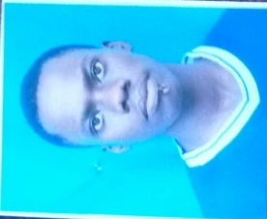**Name: GERVAS JOSEPH MAGADULA**

P O Box 65001

Dar Es Salaam, Tanzania

**Mobile: 0653934302, 0625516851**

Email: gervasmagadula@gmail.com

**OBJECTIVE:**

To acquire a challenging position where I can utilize my education background, professional experiences, strong organizational, analytical and problem solving skills and to gain further experience while enhancing your institution productivity and reputation.

**PERSONAL DETAILS:**

Gender: Male

Date of Birth: 31stMarch, 1993

Language: Proficient in writing and speaking English and Kiswahili

Nationality: Tanzanian

Marital Status: Single

Religion: Christian

**EDUCATION BACKGROUND:**

2013 to 2016 **Dar es salaam Institute of technology**

Ordinary Diploma in Building and Civil Engineering

2013 to 2015 **Dar es salaam Institute of technology**

Full Technician Certificate in Building and Civil Engineering

2013 to 2014 **Dar es salaam Institute of Technology**

Basic Technician Certificate in Building and Civil Engineering

2011 to 2013 **Galanos Secondary School**

Advanced Certificate of Secondary School Education

2007 to 2010 **Faraja Seminary**

Certificate of Secondary School Education

2000 to 2006 **Changanyikeni Primary School**

Certificate of Primary School Education

**OTHER SKILLS**

1. Computer skills
   * + Word processing by Microsoft Word
     + Spreadsheet by Microsoft Excel
     + Database Management using Microsoft Access
2. Driving skills

2013 Victory Driving School

Certificate of Driving School

Driving licence number - 4001681198

1. 2013 I attended National Service program at 824 KJ Kanembwa JKT (AG 3801)

**WORKING EXPERIENCE:**

**August to October 2014 (Field Attachment)**

**NANDHRA Engineering and construction Company Limited**

Worked as a technician in practical training during construction of Swissport cargo building at Julius Nyerere International Airport.

**August to October 2015** **(Field Attachment)**

**Afriq Engineering and Construction Company Limited**

Worked as a technician in practical training during construction of St. Joseph’s Cathedral High School hostels in msasani Dar es salaam.

**EXTRA-CURRICULA ACTIVITIES:**

* Studying and reading novels and other books
* Working with community and charity groups ( DIT Charity Club)
* Involving in religious activities
* Interacting and socializing with fellows

**REFEREES**

* **Mr. Daniel Aaron Malyuta**

Lecture

University of Dar es Salaam

College of Engineering and Technology

Dar es Salaam, Tanzania

Mobile: +255-717000290

Email: zelyutamr@yahoo.com

* **Mr. Isidory Mathias Kanuti**

Lecturer, Timetable coordinator,

Dar Es Salaam Institute of Technology (DIT),

Dar Es Salaam, Tanzania.

Mobile:+255-713413065

Email: [ikanuti62@yahoo.com](mailto:ikanuti62@yahoo.com)

**DECLARATION:**

I, **GERVAS J. MAGADULA** the undersigned, certify that to the best of my knowledge and belief, these data correctly describes my Qualifications and Experience.

**Signature**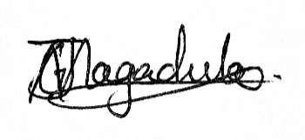

**Date 30th May 2017**